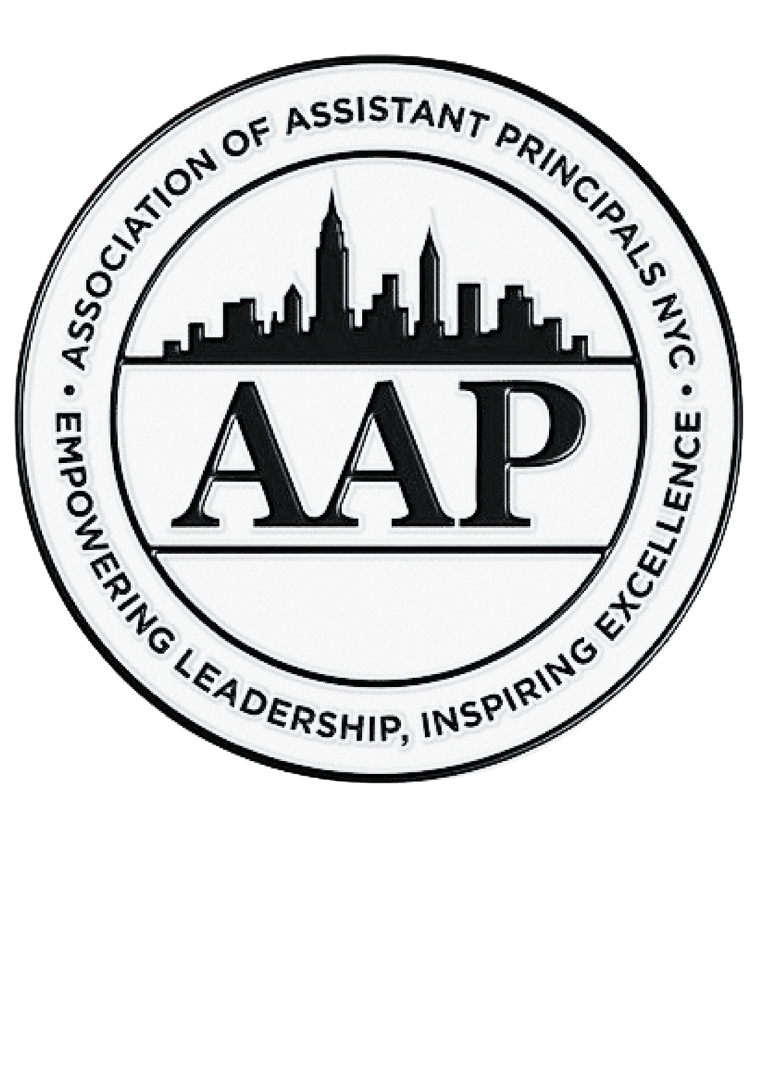

Association of Assistant Principals
Membership Application Form

The Association of Assistant Principals (AAP) is the professional association that represents assistant principals in New York City Public Schools, at the elementary and middle school levels.

By signing this, I am requesting to become a member of the AAP. I understand that dues ($5/paycheck) will be deducted directly from my paycheck by CSA for AAP membership.

I will be able to withdraw my membership at any time, by notifying CSA Members Services.

Signature _____________________________________________________

Print Full Name ________________________________________________

File Number _________________

Current School or Site ___________________________________________

Email_________________________________________________________

Please complete the membership application and mail it to:
Gail Irizarry C/O CSA , 40 Rector Street, 12FL, NY, NY 10006
Or scan the signed form and email it to: aapinnyc@gmail.com

If you have any questions about membership, please feel free to reach out to our president, Joseph Napolitano, or executive director of member services, Gail Irizarry.

Association of Assistant Principals
Empowering Leadership, Inspiring Excellence
Affiliate of the Council of School Supervisors and Administrators
Local 1 – AFSA, AFL-CIO
40 Rector Street, 12th Fl, N.Y.C., N.Y. 10006
www.nycaap.org

PRESIDENT
Joseph Napolitano
JNapoli@schools.nyc.gov

FIRST VICE PRESIDENT
Catherine Jarrat Koatz
CJarrat@schools.nyc.gov

VICE PRESIDENTS

Julianna Tramontana
JTramon@schools.nyc.gov

Tabatha Romano
TRomano4@schools.nyc.gov

Janiece Wardlow
JWardlow@schools.nyc.gov

Anthony Debetta
ADebetta@schools.nyc.gov

Dylan Larkin
DLarkin4@schools.nyc.gov

SECRETARY
Anthony Treglia
ATreglia@schools.nyc.gov

TREASURER
Cinnamon Harris
CHarris3@schools.nyc.gov

Executive Director Finance, Events, & Vendor Relations
John Oricchio
aaptreasurer1@verizon.net
Executive Director Member Services, Communications, & Public Relations
Gail Irizarry
aapinnyc@gmail.com

Newsletter Editor
Jinny Chung
JChung383@gmail.com

